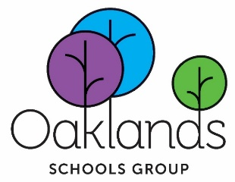

Headteacher: Mrs Mairead Standring BA Hons
Gresham Road
Hounslow
Middlesex
TW3 4BX

 020 8560 3569
 office@oaklands.uk.net
 www.oaklands.hounslow.sch.uk

HIGH OAKS SECONDARY SCHOOL UNIFORM

Oaklands High School uniform for years 7-11 consists of purple sweatshirts, purple polo shirt and a purple zip up fleece all with the High Oaks logo on them. These are to be worn with grey trousers or skirts.

Sixth Form student uniform is optional and consists of a purple zoodie with the High Oaks logo.

These items are available in the following range of sizes:

7-8, 9-10, 11-12, 13, 14-15, Adult small, medium, large, X-large and XX-large.

To purchase uniform please complete and return the slip below to the school reception together with your payment. Payments can be made via card payment only.

UNIFORM ORDER SLIP

Uniform Item | Price | Size | Quantity | Total Cost
Purple Zip Up Fleece (9-13yrs - not available in size 14-15) | £19.50
Purple Zip Up Fleece (S,M,L,XL) | £23.50
Purple Sweat Shirt (9-13yrs - not available in size 14-15) | £15.50
Purple Sweat Shirt (S,M,L,XL) | £19.00
Purple Polo Shirt (11-15yrs) | £12.00
Purple Polo Shirt (S,M,L,XL) | £13.00
Purple Polo Shirt (XXL) | £16.00
White PE T-Shirt | £12.00
Purple Zoodie (for 6th form) S,M,L | £23.50
Purple School Book Bag | £16.00
Black PE Drawstring Bag | £8.00

Name of Student ………………………………………………………………………………………………

Name of Parent/Carer ………………………………………………………………………………………

Payment method: Card

Date…………………………………………………………………………………………………………………

