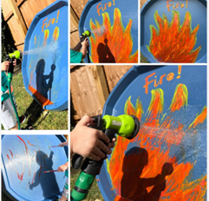
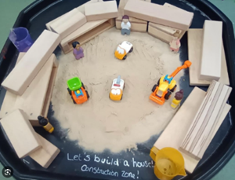
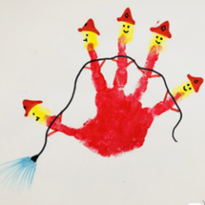
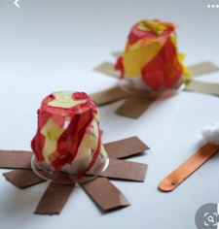
English:
Phonics- This term we are looking at Phase 1 of Jolly Phonics : Jolly Phonics Phase - S-A-P-T-I-N Songs with actions and vocabulary. - YouTube
Phase 1 Phonic Sound Help with Pronunciation - YouTube
Reading-Books we are focusing on:
Writing – Encourage your child to practice writing ‘s, a, p, t, i, n’ letters in line with their phonics work. You can do this using sensory textures such as sprinkles, playdough and pipe cleaners. Using a chalk board you can try the ‘wet, dry, try,’ method. First role model writing the letter, trace it with a wet sponge, dry it and then encourage your child to try writing the letter.
Maths:
Shape, Space and Measure – Recognizing patterns using puzzles, number lines, colour and shape sorters, making puzzles using pictures of student’s family members, create 911 using red orange and yellow patterns
Numbers- learn turn-taking opportunities using number songs, ordering numbered pictures of our families, matching cars with the correct police officer (matching numbers), rescue the numbers
Counting and sequencing- counting our fingers during group sessions, counting peers and members of staff in my class, counting large groups of people in ‘family photos’, listen to the song and then line the correct amount of firemen to help put out fires

Expressive arts and design
Art- Textured School Collage, tactile name cards, 3D fire art, use your handprint to create the 5 little firemen
Music- Listening to songs related to our topic “People Who Help Us” and modelling Makaton signs.
Makaton signs- Makaton - FIVE LITTLE FIREMEN - Singing Hands - YouTube
Homeworking idea: Role model the Makaton signs for “toilet”, “more”, “finished”, “lunch”.

PSED:
Following daily routines including snack time, lunch time and home time. Look at developing toileting routines using objects of reference and visuals.
Homeworking idea: As part of your toileting routine at home use a toy, song or object of reference to indicate its toilet time. Encourage your child to sit on the toilet using a timer and make note of their progress. Promote independency during dinner, by encouraging your child to use cutlery.

Early Years-Autumn Term
Topic for this term:
People Who Help Us
(Areas covered: My family and my school, Community helpers, Medical and Health Professionals, Me helping others)

Understanding the World:
- Achievement assemblies
- Whole school celebrations (Harvest Festival, Black History, Diwali, Children in Need, Christmas).
- Turn taking during outdoor exploring of the school using the swings, roundabout and trampoline
- Parachute games during outdoor learning
Homeworking idea: Encourage students to take turns with family members, while sharing their favourite toys

Gross motor:
Obstacle activities children moving over, under, through and around equipment. Circuits, walking/ running games/ daily mile
Fine motor:
Pre writing- sensory play/different textures, developing shoulder stability/ hand strength with therabands.

