English: Reading Schemes Homeworking
Go to www.oxfordowl.co.uk
- Click on Oxford Owl for Home:
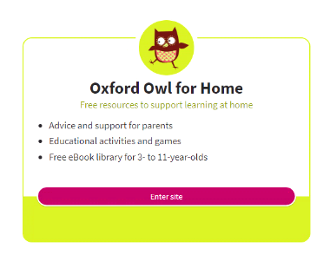
- Click on Free eBooks for ages 3-11
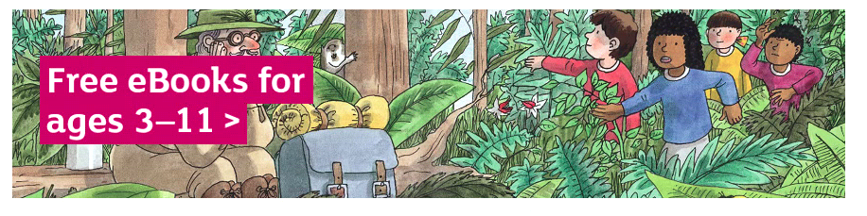
- You will need to register for a free account and verify your email address.

- Under ‘Browse the library’ click ‘levels’ and select the appropriate colour for your child. The class teacher can help you with this if you aren’t sure.
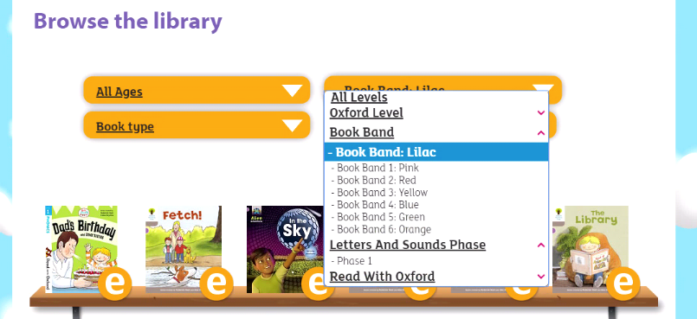
- Select an ebook, which will open on PC or tablet. There is an audio option so students can listen to the story or read the words themselves.
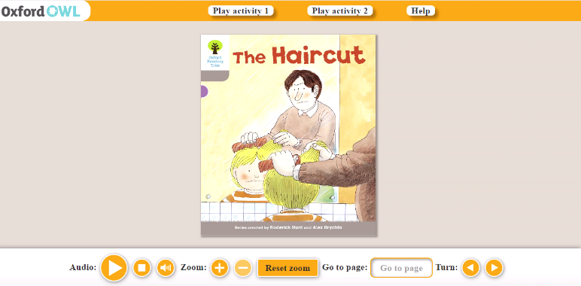
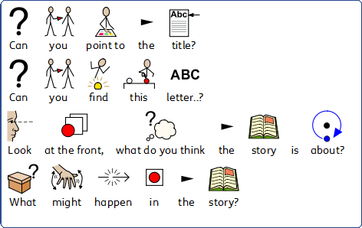
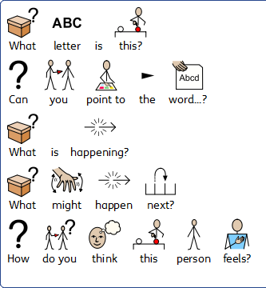
Questions to ask before reading Questions to ask during reading

Questions to ask after reading


